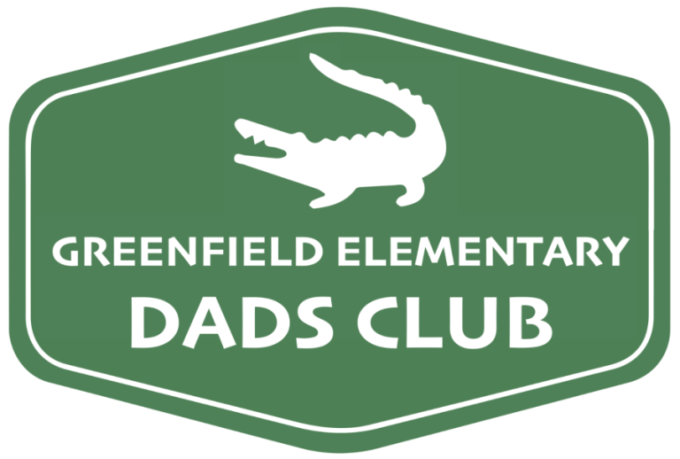
Subject: Support Request for Greenfield Elementary Dads Club Fundraiser
Hello ,
The Greenfield Elementary Dads Club, dedicated to enhancing the experience of students and staff at Greenfield Elementary School, Gilbert AZ, is excited to announce our upcoming raffle fundraiser event.
In our effort to raise funds for school improvements and extracurricular activities, we are reaching out to local businesses for raffle donations in the forms of goods, services, or gift cards. Your generous contribution will play a crucial role in enabling us to continue our mission of providing valuable experiences for our students and staff.
To give you an idea of our most impactful services, we annually gift 14 students with new bikes, organize a petting zoo for our fall festival, host a cherished Donuts with Dads event, and culminate each school year with our popular Truck Night. The Greenfield Dads Club operates as a 501c3 non-profit organization, and our tax ID number is 87-3695469.
Thank you for considering our request. If you are able to support, please let me know and we can discuss item pick up and additional details. If you have any questions or comments, feel free to contact me at 623-826-2990.
Sincerely,
Jordan Alsop
Greenfield Elementary Dads Club President
623-826-2990
greenfielddadsclub@gmail.com

